|  |  |
| --- | --- |
| Roll No. A030 | Name: Romil Shah |
| Program: B. Tech | Division: CSBS |
| Batch: B2 | Date of Experiment: 5/09/2020 |
| Date of Submission: 6/09/2020 | Grade: |

**Practical 7**

**(PART – A)**

***Aim: To develop a Turing machine.***

**Outcome:** After successfully competing of this practical, students will be able to learn:

* What is Turing machine?
* How it works?
* How to convert Turing machine to unrestricted grammar?

**A.1 Reading**

Read Page 70 to 102 of lab manual.

**A.2 Tasks**

1. Develop a single tape turing machine for the language L = {anbncn} for n > 0 using JFLAP tool.

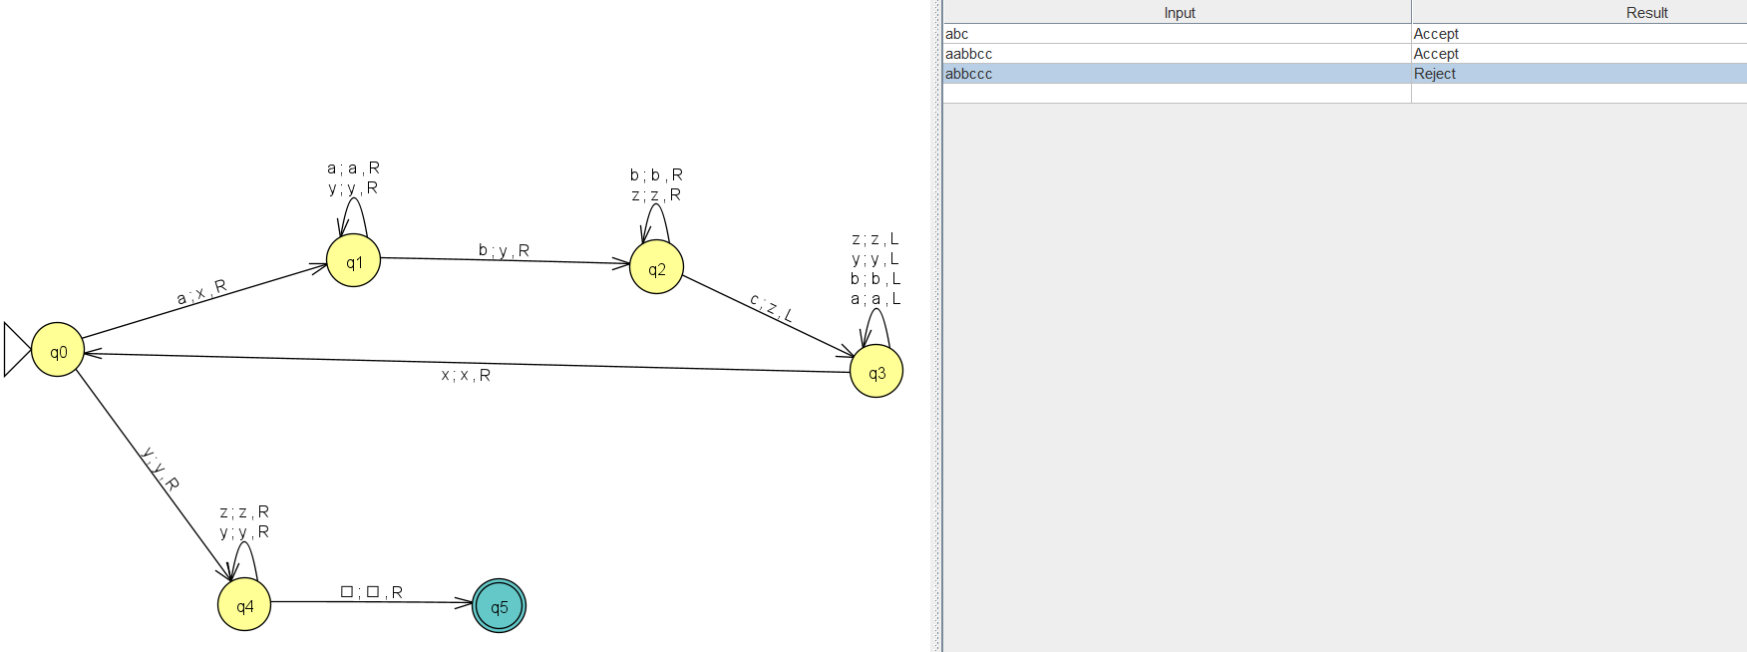

1. Convert it to unrestricted grammar using JFLAP tool.

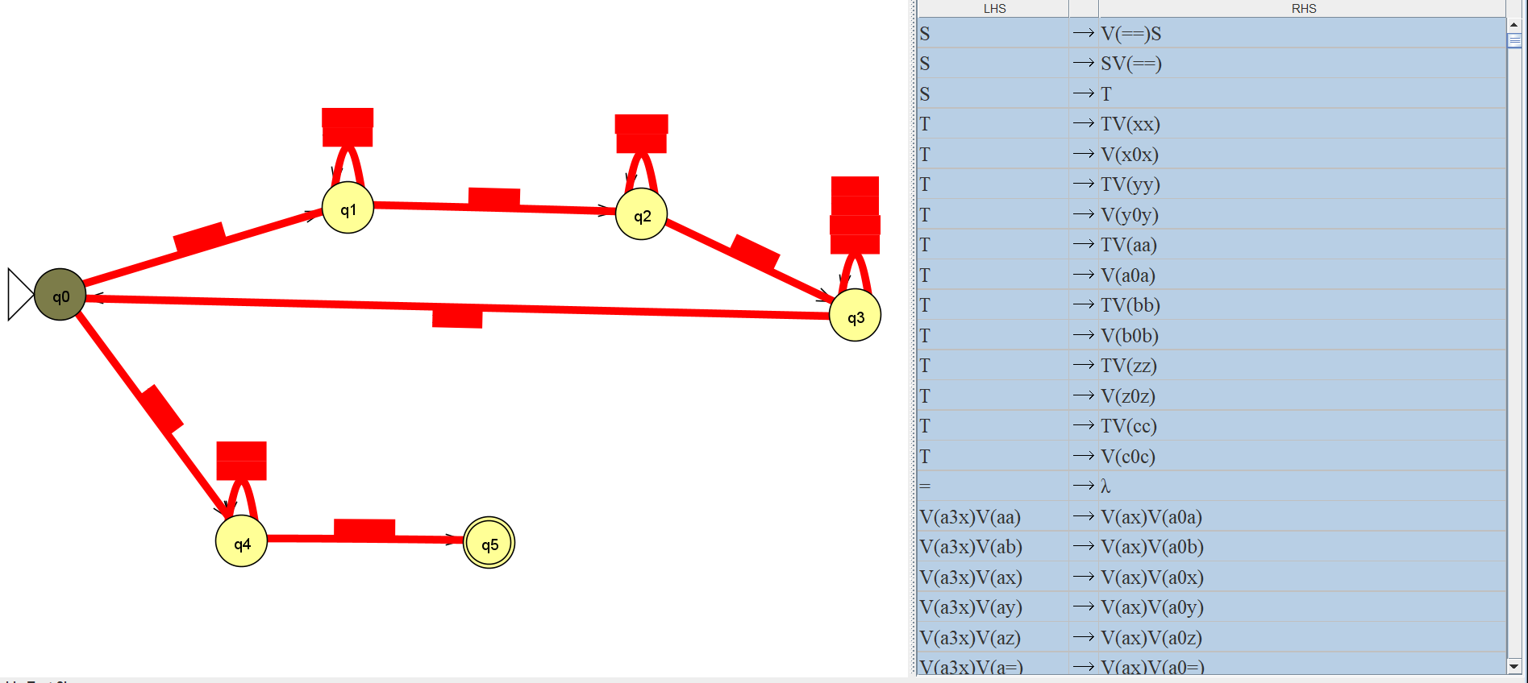

**PART B**

**B.1 Output:**

1. Write a procedure to generate the Turing machine using JFLAP tool.

1. Open JFLAP tool and click on Turing machine.
2. Create required number of states using state creator.
3. Create required transitions using transition creator.

2. Write a procedure to convert Turing machine to unrestricted grammar using the JFLAP tool.

1. Go to convert option.
2. Click on convert to unrestricted grammar.
3. Click on show all.

**B.2 Observations/Learning**

We were able to design a Turing machine for the given language and successfully convert it to unrestricted grammar.

**B.3 Conclusion:**

Turing machine accepts the strings that contain equal number of a’s, b’s and c’s.